|  |
| --- |
| Printervalley |
| Prusa I3 Build manual |
| [Type the document subtitle] |

|  |
| --- |
| Marco van Noord  12/4/2013 |

Contents

Introduction 2

Necessary tools 3

Step 1: wooden frame 4

Y-axis 5

Printbed 8

Print bed 10

X-axis 11

# Introduction

Thank you for purchasing the Prusa i3 from Printervalley.com.

With the help of this manual, you can build your own 3d-printer in about 1-2 days time, depending on your mechanical skills and knowledge.

# Necessary tools

Since this printer comes as a kit, you will need a couple of tools to build it all together. The most important tool, a 2mm hex wrench, is in your box with parts. The other tools you might need are:  
  
 - socket wrench 13

* Monkey wrench
* Soldering iron
* Flat screwdriver
* (Stanley) knife
* 3mm drill
* Sandpaper
* Ruler/measuring tape
* Patience

Before we start, it’s a good idea to lay out all the parts on a table and to examine them carefully, so you will have a general understanding which parts are supposed to serve which goal.

I would advise you to read the whole manual first before starting.

Some general tips:

* Try to use washers where you can. They distribute forces on either plastic or wood, which will prevent them from breaking.
* Since all parts are printed, it is possible some holes aren’t big enough. You can use a small file, some sand paper, a drill or a rod which has been held above a flame to make things fit.

# wooden frame

We will first put the wooden frame together.

First, grab the big square frame. This is the centerpiece of your printer.

Now, take the two triangular pieces, and examine them. One of both has a slightly bigger hole in it than the other (12mm vs 10mm). This will be the left side of your printer.

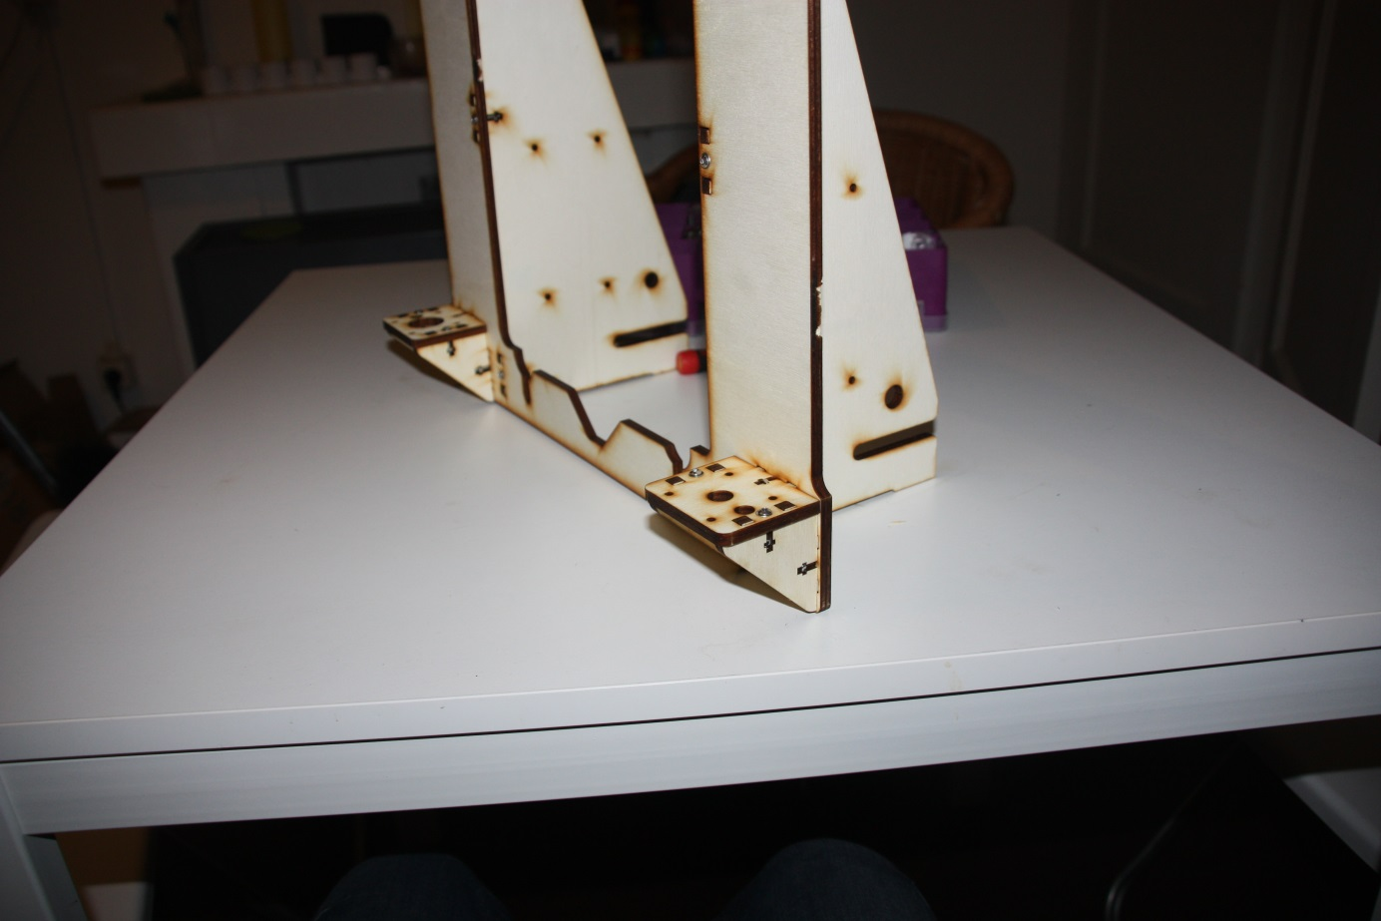Now take both parts, and put them in the designated slots in your square frame. Not that the frame doesn’t have a left or right, so you cannot really do this wrong. Put a nut in the 6 t-slots and fix them with a 16mm M3 bolt with a washer.

Next, take the four triangle wooden parts and their accompanying square counterparts. Mount them as in the picture, taking care that the one with the bigger hole is on the left side.

Your wooden frame is now mostly done.

# Y-axis

The y-asis is your table that slides forth and back. It will be made of some pieces of steel, held back together with the 4 printed corners.

First, take the longest pieces of M8 rod (38cm) and 35cm, 8mm smooth rod. They should be about 38cm long. Take some nuts, the four printed corners and three lm8uu linear bearings and put it together like in the following configuration. Use some sand paper or a file to get rid of any sharp edges on the ends of the rods, as so not to damage the bearings. Don’t over tighten things, just tighten everything by hand.

Note that the part with only one bearing will become on your printers left side, which is seen with the triangles sticking to the back.

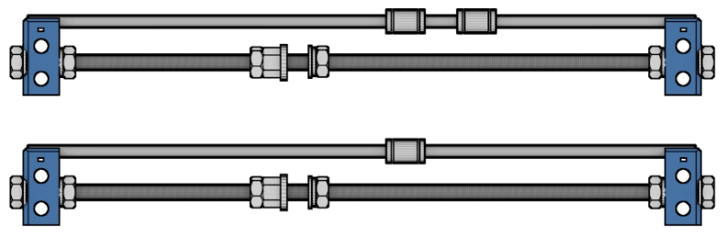

Now, we take the three remaining rods, together with the motor mount (the part with 4 holes), the y-idler, and put it together like this:  
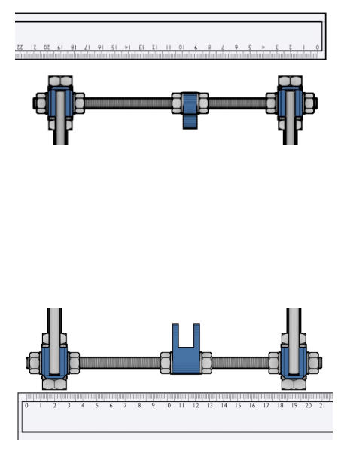

All rods should be the same, except for the back top rod. That should be the longer rod. This is what will give the printer most of it’s stability.

Now we will take the last wooden part and test-fit it on the linear bearings. Don’t attach things yet, since it will make assembly a bit harder, but see if it fits nicely on those bearings. Slide it up and down to see if the left and right rods are perfectly parallel. Adjust them if necessary.

Next, we can put the x-axis in the wooden frame. Put a nut and a ring on either side of the longer rod and slide it between the slots in the triangle parts. Now slide the lower rods in the main frame. Measure it (see image) and tighten them carefully. Having a 90 degree angle is very important, so be sure to check that too.

You can now tighten all the nuts a bit more with a 13mm wench, but be sure to take care so not to break the plastic parts.

Note that the image has the linear bearings switched, and that it’s missing the longer rod in the back.

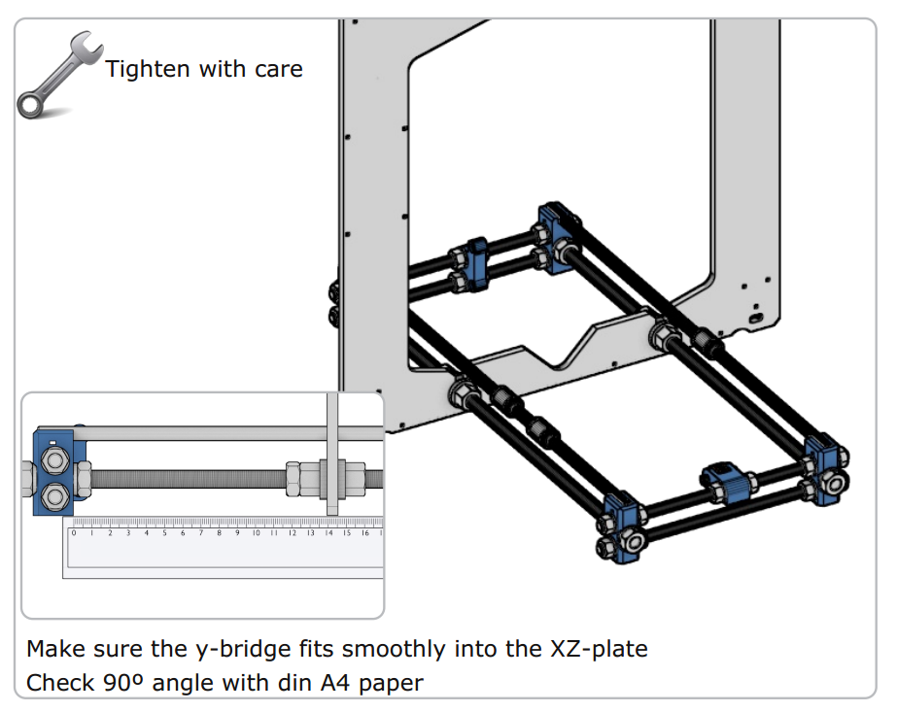

# Printbed

Now that the y-axis is done, we can put the printbed in place. First, we put a pulley on the motor and then we fix the motor to it’s mount, with the motor facing to the LEFT.

It’s now time to take two of the smallest bearings, and fix it in the idler with a 30mm screw. These two bearings will guide the y-belt.

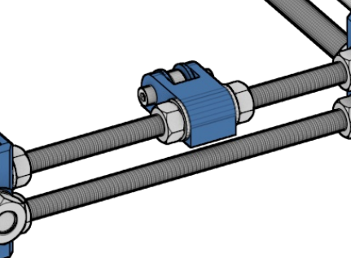

It’s time to fix the belt holder to the underside of the wooden printbed. Make sure to put the nuts in the designated nut trap.

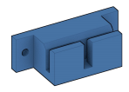

Next, grab the printbed and put it on top of the linear bearings.

Now grab the y-belt, and put it through the idler and over the pulley. Be sure that the idler and motor line up with the belt holder. If not, you might experience some increased wear on the belt, so adjust those so they are perfectly in line.

Now everything is in place, you can fix the bed to the bearings with the zip ties. Be sure to put the end of the zip tie on the underside of the bed. Pull them tight and clip the endings.

Now slide the belt into one slot of the belt holder and tighten it with zip ties. Make sure to leave enough length to do this with the other side.

It might be possible that due to differences in printed parts, the ribbed side of the belt holder isn’t close enough to the belt, so the belt slips away. You can solve this by putting some m3 washers between the top (smooth side) of the belt and the belt holder.

Now one side is done, you check that the belt isn’t twisted and fix the other end of the belt like below. Make sure that the belt is relatively tight. Now your y-axis is done, and you should already see your printer taking shape!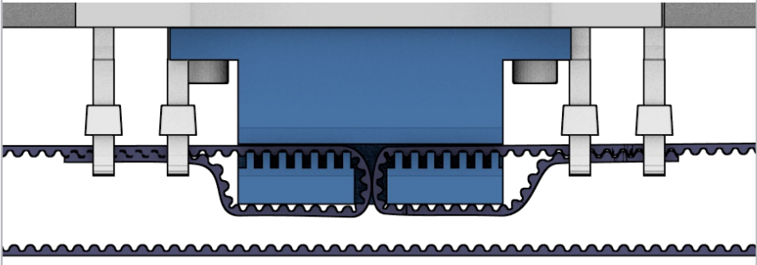

# Print bed

We are going to put the acrylic print bed on the wooden bed.

We do this by taking 4 20mm screws and put a washer on them.

Now, put them through the acrylic. Get the four bed springs and push them on the screw, the small side first. It might need some minor adjustment to the springs to make them fit.

Next, comes the tricky part. It’s best to lay the printer on its side for this, or have someone help you.

Put the bedscrews through the wooden bed part, and fix it together with a nut. Be sure not to tighten them, just make sure the nut doesn’t fall of; we will later on adjust everything.

# D:\Dropbox\Projects\supermaker\Manual\x-ends.pngX-axis

The x-axis is the part that slides left and right, carrying the hot-end and the extruder drive.

We start by taking the x-motor part and x-idler.

We take four lm8uu linear bearings and press them into their designated area.

They are designed to sit very snugly, so it might take some effort to get them in. A flat screwdriver to open up the hole a bit might be necessary, just be careful not to break it.

Insert two M5 nuts into their nut trap.

Now get a 608 bearing(the biggest ones) and fix it with a 30mm screw. Be sure to put the nut on the same side as the M5 nut. It might be a smart idea to use some washers to make sure the bearing sits nicely in the middle between its sides.

Now get those 37cm long smooth rods, and put one linear bearing on one of them, and two on the other. Use some sand paper or a file to get rid of any sharp edges on the ends of the rods, as so not to damage the bearings.

We can now push the rods into the ends. The rod with two bearings goes on top, the other one on the bottom. The ends are made to be push-fit, so with some force, you can get them in, and there’s no need to fix them. If you really can’t get them on, carefully use a 8mm drill to open up the holes. There should be 30,5cm of rod between the two ends.

Now, we can put the x-axis aside, while continuing with the Z-axis

# Z-axis

First, grab one of the motors, and fix it on the left side in the motor holder. Fix it with some 10mm screws with a washer.

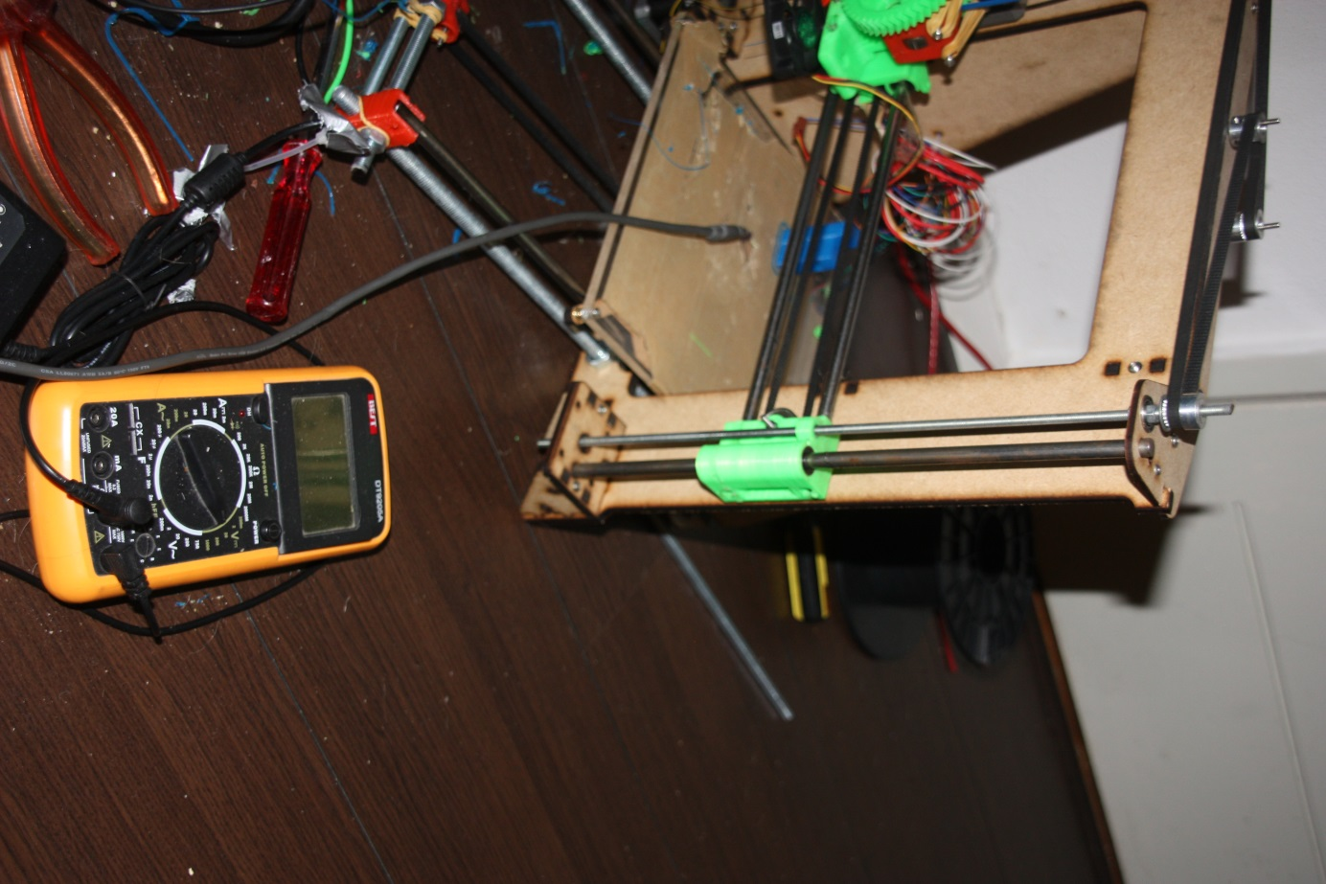On the right side, you fix the small square wooden part that’s left. Put it against the underside of the mount, so the smooth rod won’t fall out later.

Get the remaining smooth rods and put them through their slots in both of the motor mounts. The left should lean on the motor, while the other leans on the wooden part you just installed.

Next, it’s time to put the x-axis on the smooth rods. Just let it rest on the bottom. Meanwhile, get the 5mm threaded rods. Make sure that you put the longer one on the right side. Also, don’t forget to double-check if the 5mm nuts are in the 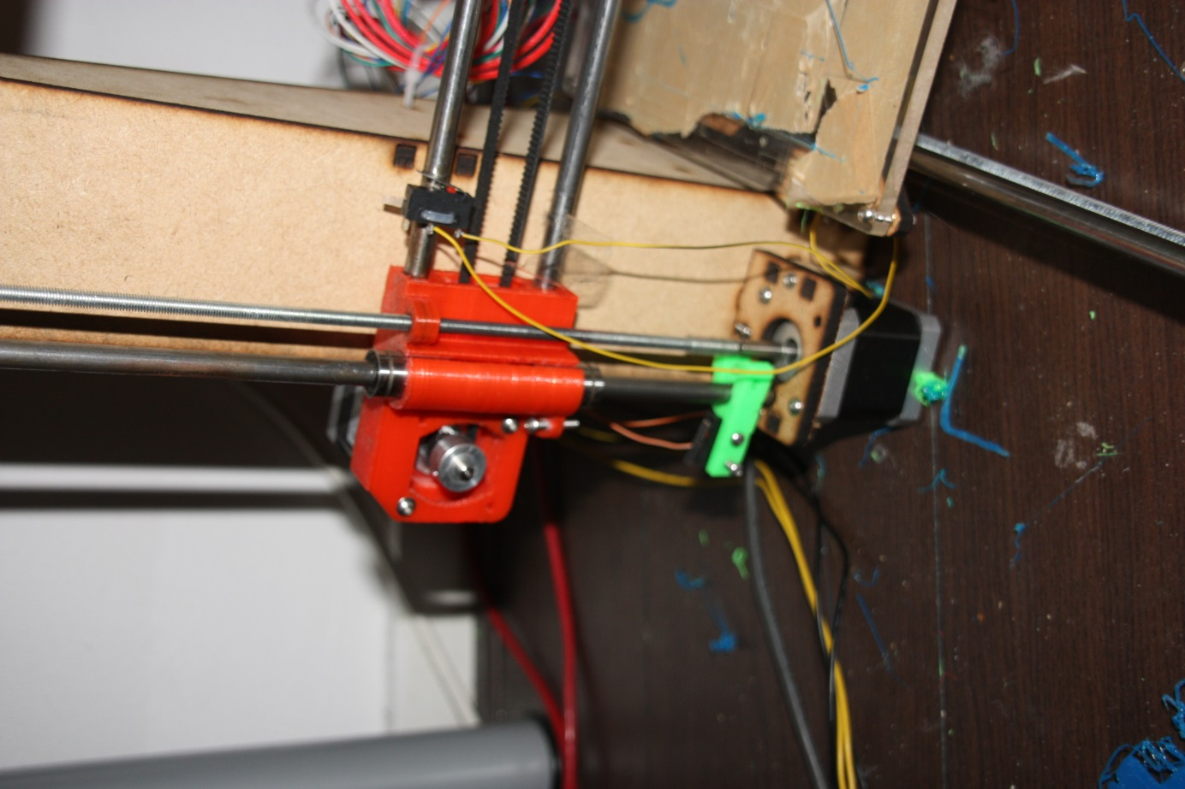nut traps of the motor-end and the idler.

Get the clear aquarium tubing, and cut it to 4cm length.

Now, heat it up a bit, with your hands or a hairdryer, to make it a bit softer.

Push it on the motor shaft. Get the short 5mm rod and screw it through the motor-end. After that, push and turn it into the aquarium tubing, just like below. Make sure that you leave approximately 1-2mm between the motor shaft and the threaded rod.

Screw the long threaded rod into the idler-end.

Now, you should have something similar to the images on the right.

Next part is to put the long wooden part on top of the frame, and screw it 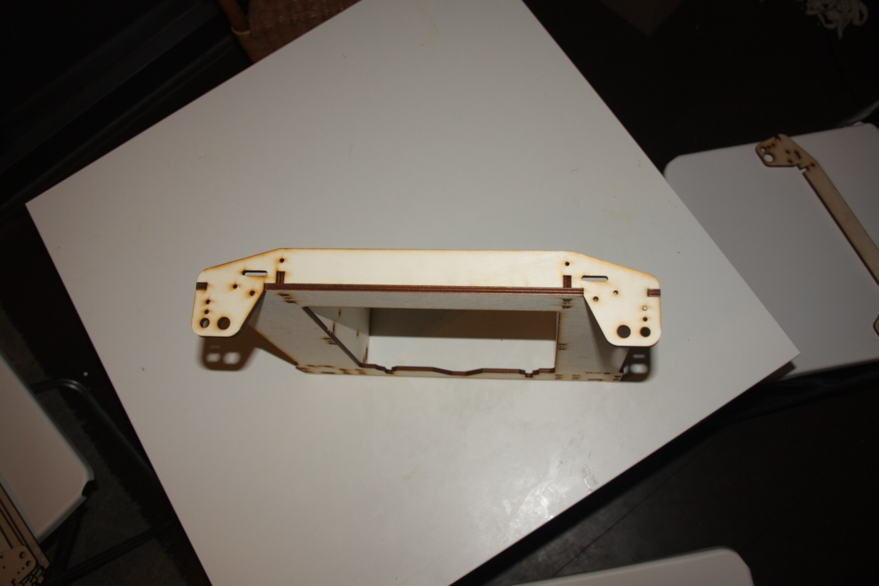 on the top, while putting both smooth rods through the outer holes.

The 5mm threaded rods should go through the inner holes.

Now grab another 5mm nut, and screw it on, just below the wooden top part.

Get the bearings for the z-axis, and put them around either of the 5mm rods. They should sit snugly in the wooden holes. If not, use some glue to keep them in place, of course making sure not to get glue on the moving part of the bearing.

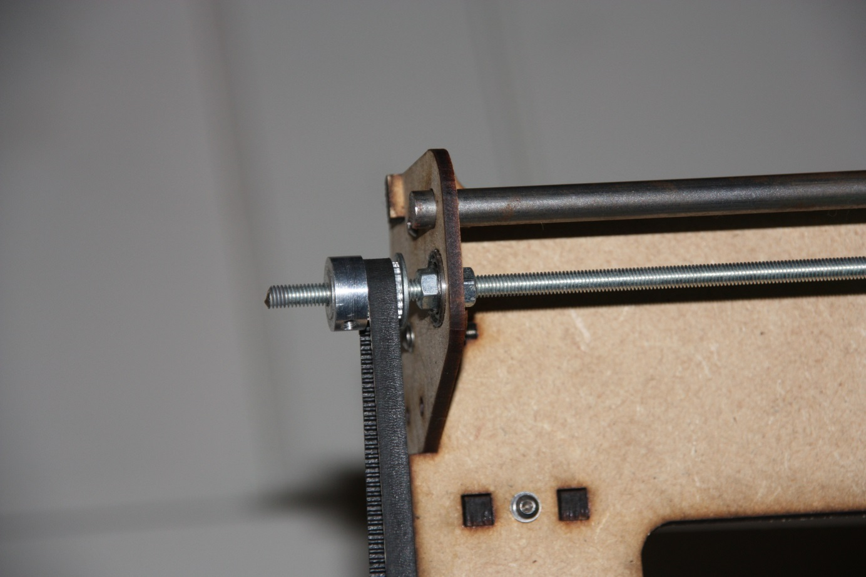Screw the 5mm nuts a bit back, so it touches the bearing, and put another one on top of it. On top of that goes one of the pulleys. This way, you get a nice pulley-nut-bearing-nut sandwich. Do this with both sides. After loosely putting the z-belt on there, you should have something like this:

Now, there are a few holes and slots on the top wooden part left. We’re going to use them to tighten the bolt. Grab a long 30mm bolt, put it through one of the holes, and put a nut on it. Use a washer, a small bearing and another washer to make a belt-tensioner. Make sure your pulleys and your bearings are on the same level.

When done, you should have something that looks like this:

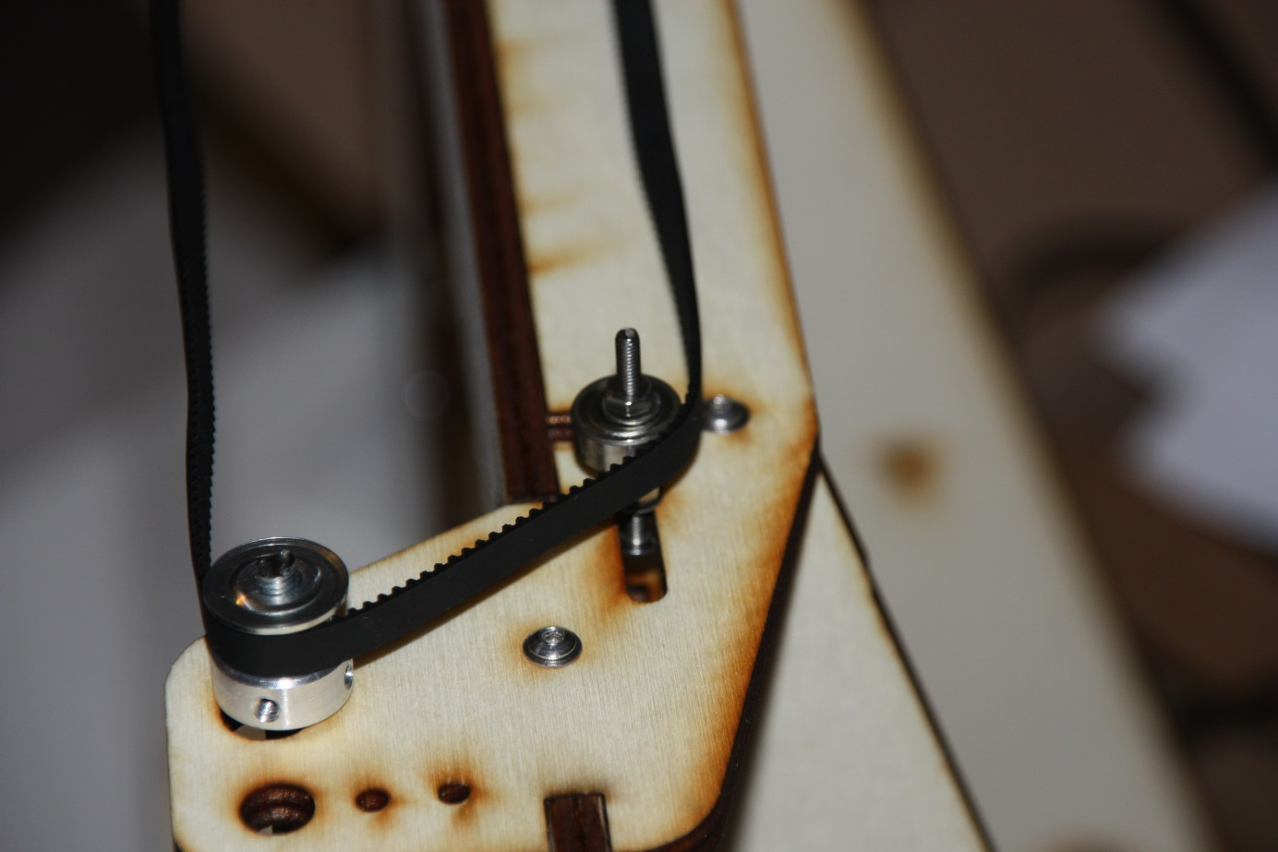We’re not going to tension them yet, since we need to align our x-axis first. But first, time to put our printer aside for a bit and to focus on the part that is going to do the heavy work later on.

# Hot end

We start off by grabbing the idler hinge, see the image on the right. We grab one of the 608zz bearings, put the 8mm, 20mm long rod in it, and force it into its slot. This might require some force.

We now grab the cold end (that’s the biggest piece of plastic you have), and fix the idler on it with a screw and a nut, if necessary.

Grab the two other 608zz bearings, and push them in both sides of the 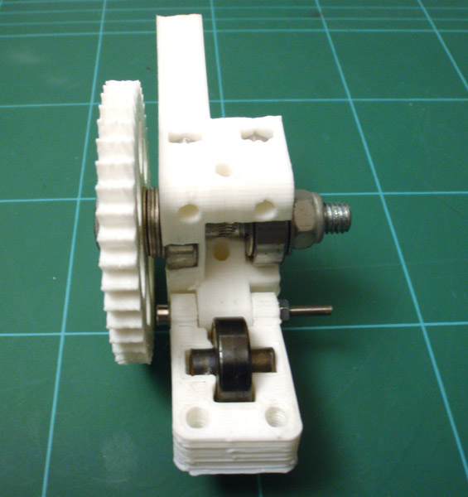 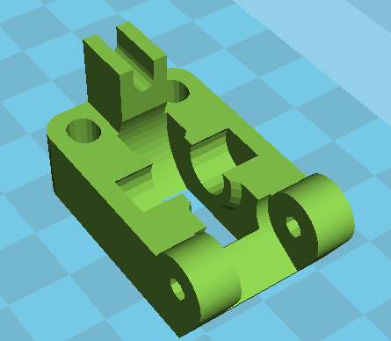cold-end.

You might need to remove some material, but make sure both bearings sit really tight in there.

Grab the Waynes hobbed bolt, that’s the M8 bolt with the weird cut in the middle, and put it through the large herringbone gear. Get 2-3 M8 washers, put them on the bolt and push the bolt through both of the cold-end. Since the hobbed part might have become a bit thicker, you might need some force. Putting a file flat on the screw to file a bit off is also fine. Just make sure not to damage the sharp teeth, that will eventually grab into the filament.

Your cold-end should look somewhat like on the image on the right, except for the different gear. You also don’t need the M8 nut on the right.

Next, grab another motor and put the small herringbone on there. There’s only one way it will later grab into its big brother, so make sure not to put in on backwards. With a nut in the small gear and a 10mm screw you can make sure it won’t slip.

It’s time to mount the motor with the three mounting holes. Use a washer and the 10mm screws. Make sure the gears are touching, but not grinding.

Next is to grab the hot-end, it should fit into the underside of the cold-end. You can fix it with two 16mm screws. Make sure the hot-end is completely in, before fastening the screws, as not to break the PEEK (that black plasticky stuff on the hot end).

Make sure the wires are on the gear-side, and you can use a tie-wrap to fix them to the motormount, if you want. 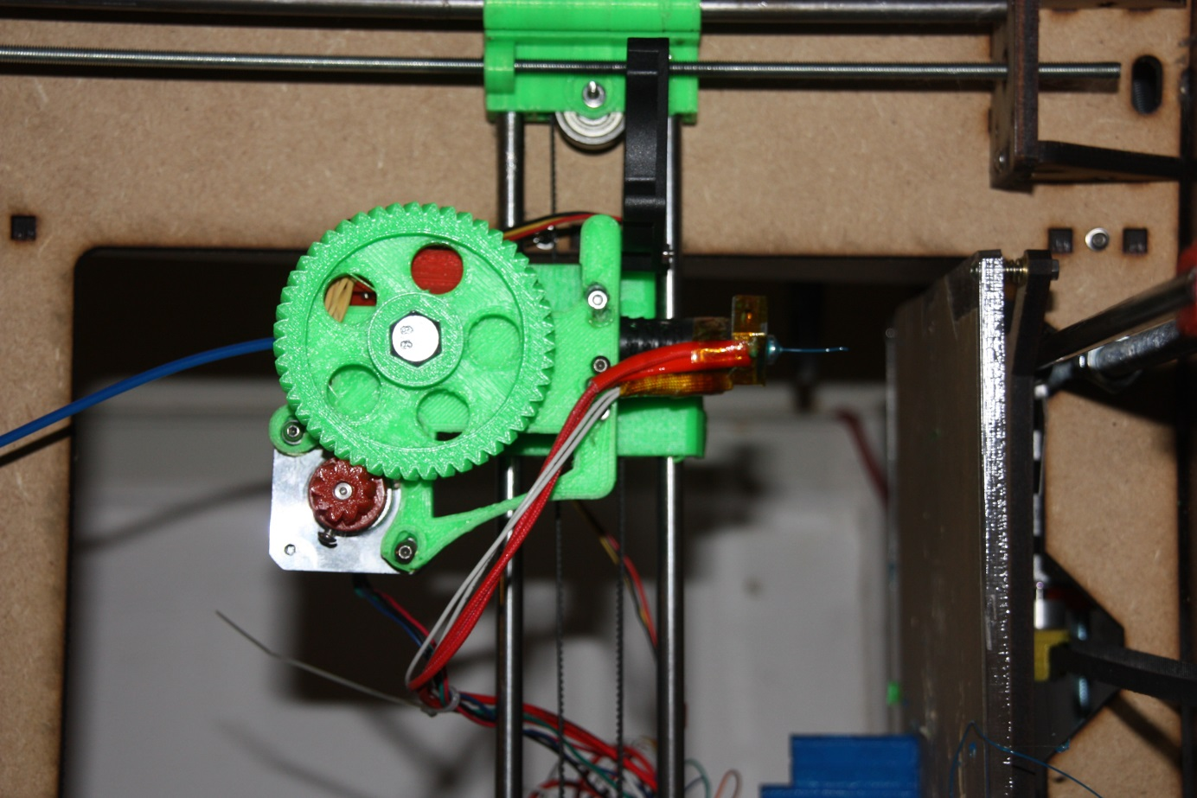

Now it’s time to grab two m4 nuts, and put them in the two slots on the top. Grab the two m4 screws put the two springs on there. It might be an idea to crimp the end that is touching the head of the nut, so it won’t fall off. Alternatively, you can use a washer of some kind.

Push the two bolts through the idler-hinge, all the way into their nut. By tightening, you can increase the amount of force the idler exerts on the filament, to prevent it from slipping, but we’ll do that later.

Next is to grab another two m4 screws and put them all the way through the cold-end, next to the holes where we just fixed the hot-end.

Now, grab the x-carriage, 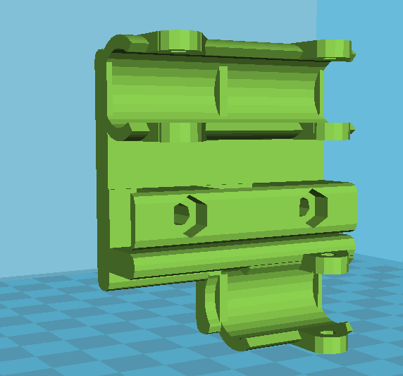and push it onto the linear bearings on the x-axis, but before doing that, put two m4 nuts in there, and make sure that the m4 bolts will fit through the hole.

The carriage should be sitting tightly onto the bearings. If not, you can use some tie wraps to fasten them, using the holes in the carriage.

Now, grab the cold-end, and screw it through the carriage, and straight through the nut. Make sure everything is tight to avoid any shaking later during printing. Refer to the image on the right-top to see how it should look now.

Now we grab the last motor, and put the last pulley on there. Make sure to put it on backwards: the pulley part first and the part with the locking nuts last. Don’t forget to tighten the locking nuts.

You can now mount the motor onto the motor-end with some 20mm screws. After that, it’s time to grab the x-belt. Get one end through the idler, and the other end over the pulley. The open end should be in the middle, at the bottom. We’re going to fix it in the carriage in the same way as with the y-axis. Put one end in the holder, and fix it with a tie wrap, put the other end in there pretty tight and fix it with a tie-wrap again.

We should now have a working x, y and (almost working) z- axis.

Now, grab a ruler, and measure the gap between the underside of the x-motorend and the motor holder. Now turn the right 5mm rod, to put it at the same level. Double check the x-axis to see if it’s completely level. If not, re-adjust until completely level. If your x-axis isn’t level, you will have a lot of problems with your first layer not sticking to the bed.

When you’re completely done, tighten the z-axis belt with the tensioners you made before. This way, your z-axis won’t go out of sync, thus leaving your x-axis parallel.

Now, we’re pretty much done with the mechanical part, congratulations if you made it this far. If you’re not this far yet, also congratulations, because it means that you’re reading the manual before starting.

# Endstops

Since we use stepper motors, we have no direct way of knowing the position of our bed and carriage.

To solve this problem, each time before a print starts, your motors will move towards their starting point, until it hits the endstop. It uses this to calibrate itself.

For the x and y axis, the position of the endstop isn’t very crucial, it just determines where on the bed your print will start.

However, your z-endstop is very important in getting your prints right. It determines the distance between your hot-end and bed on the first layer. If this is off by only 0,2mm, you can run into problems like the filament not sticking to the bed, or even worse: the hot end digging a grave in the printbed.

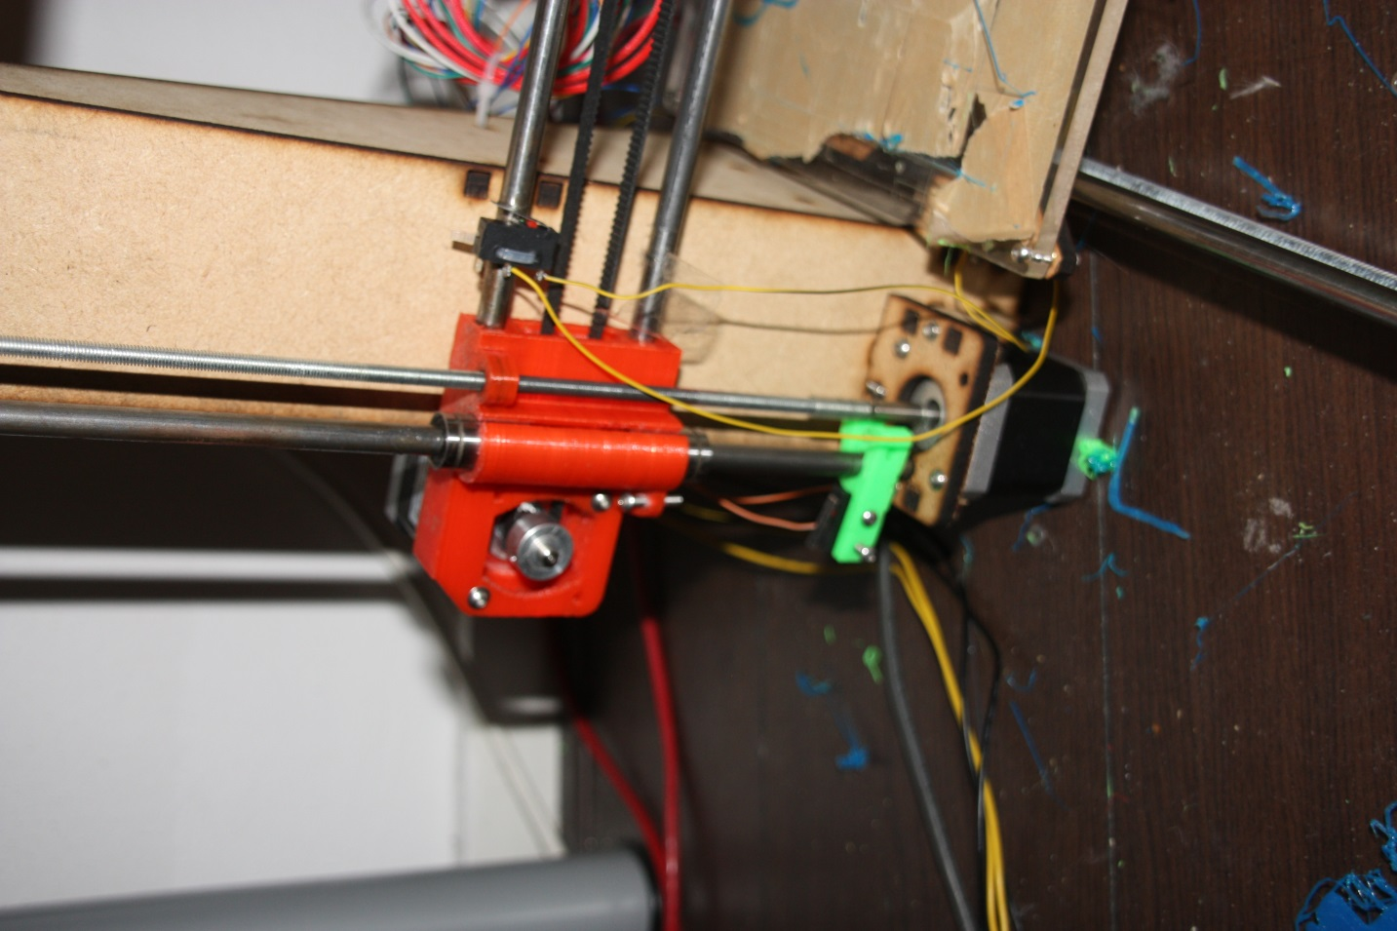For these reasons, we will need to make sure that the endstops are placed correctly.

First, we start by grabbing the three endstops, a soldering iron and the three 2-wired colored cables. Strip the end of them, and put a bit of tin on them.

Now, 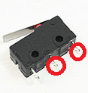solder the two wires to the points indicated in the image. Do this with all endstops.

We can now mount the x and y endstop directly to the frame. Grab a tie wrap, put it through the hole in the endstop, around the smooth rod and back through the endstop. Make sure you tighten it, so it won’t move later on.

The position of the x and z-endstop is seen in the image on the right. The y-endstop goes on the back, on the left smooth y-axis rod. Make sure the linear bearing of the bed touches the switch.

For the z-axis, grab the plastic endstop-holder that looks like the letter “h”. Using two 10mm screws, fix the z- endstop onto it, and push it onto the smooth rod, as seen on the image.

Grab a 20mm screw and put it in the x-motormount, and screw it halfway through. Now lower the z-axis with your hands, making sure that the screw hits the endstop, the moment the hot-end touches the table. If the endstop-holder isn’t very tight, use a tie wrap or screw to hold it in place, using the holes that were printed in the endstop-holder.

Images courtesy of open3dengineering.org